# **PY105 Discussion Quiz 7**

# **NAME: Carlos Lopez Section: M6 Table:N/A**

A block (of unknown mass) on a string wrapped around a pulley, which is a uniform solid disk of radius *R,* mass *M* = 6*m,* and rotates without friction about the center, so 

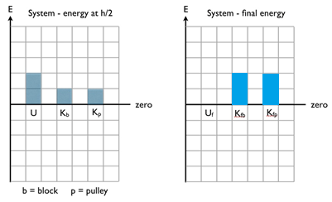The system is released from rest.

**Approach 1:** define the system as the Earth, the block, the pulley, and the string.

The energy bar graphs are shown when the block, after being released from rest, has fallen through a height of *h*/2. Sketch the energy bar graphs for the final situation, when the block has dropped through a height *h*, where the final potential energy is zero.

Determine the mass of the block, in terms of *m*. **Hint**: Write out the five-term energy equation for the system. 

Kb = Kp Kp=(.5)Iw^2=(.25)Mv^2

Kb = .5m’v^2 |________|

.5m’v^2=(.25)Mv^2 < _____________/

m’ = .5M

m’**= 3m**

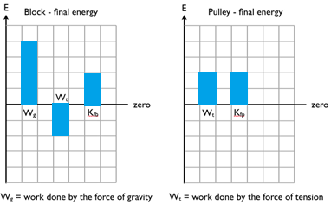

**Approach 2:** Now, we’ll look at two separate pieces of the system, just the block by itself and just the pulley by itself. Again, sketch energy bar graphs for these two objects after the system has been released from rest and the block has dropped through a height *h*. Note that the initial energy bars would all be zero.

Determine the tension in the string, in terms of *mg*.

Wt=Th Wt = (.5)Wg

Wg=3mgh

Hence,

Th = (3/2)mgh

T = **(3/2)mg**